38.40: The change in wavelength of the scattered photon is given by Eq. 38.23
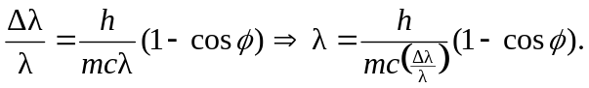
Thus,
